Visual aids
An autistic person may feel anxious before going to a new venue for the first time. Knowing what to expect can help reduce this anxiety. Visual aids can help to clarify the expectations of what the venue looks like and how to get there.
Car route to Family group in Locking church centre
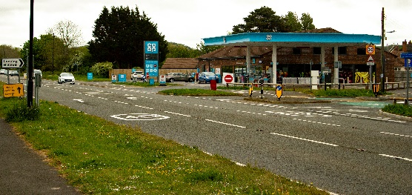  Approaching from Weston-super-Mare take the right turning on to the B3368 next to the Locking Co-op | 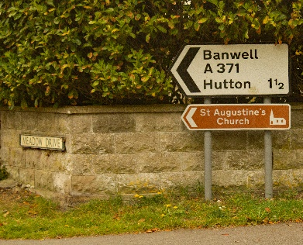  Follow signs for St Augustine’s Church | 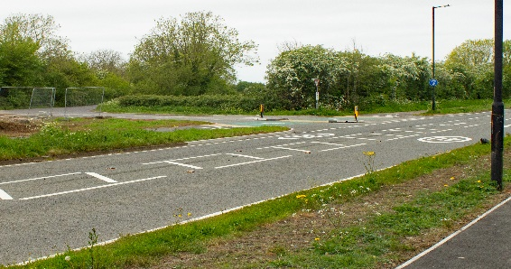  If Approaching from the Banwell direction take this turning and follow signs for St Augustine’s Church | 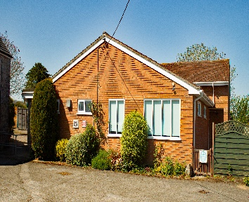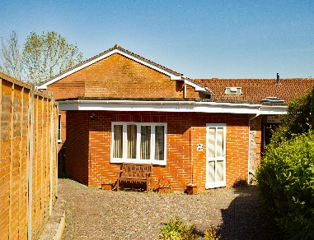  Parking is Available in the Church Centre car park. Entrance to the hall is up the left side path next to the fir tree. This leads into the main hall where the Family group will be held. We are the only users.
Address: St Augustine's Church Centre, The Green, Locking Weston-Super-Mare, North Somerset, BS24 8DA

Visual Aids
An autistic person may feel anxious before going to a new venue for the first time. Knowing what to expect can help reduce this anxiety. Visual aids can help to clarify the expectations of what the venue looks like and how to get there.
Bus/walk route to Church Centre
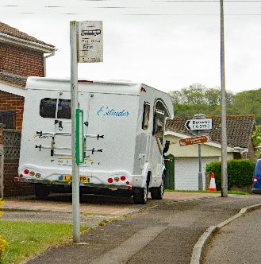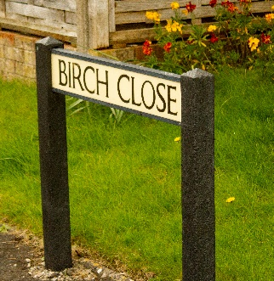  If approaching from Weston-super-Mare take the 126 bus to Locking and get off at the stop at the top of Mendip Rise next to Birch Close. | 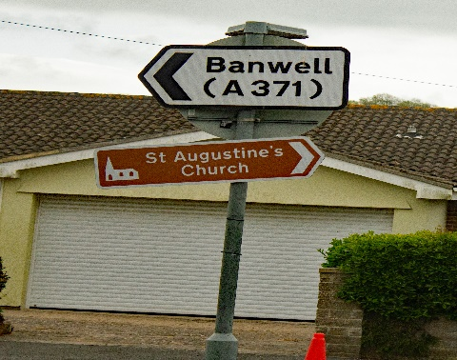  Follow the signs for St Augustine’s Church. | 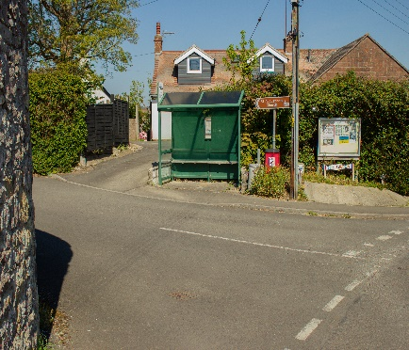  If approaching from the Banwell direction on the 126 bus remain on the bus until the bus stop at The Green and the stop is right outside the church centre. | 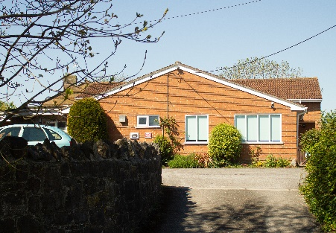  As you walk in from The green the Church centre is on the right.

